**The calligraphy Hub**

User Guide

|  |  |  |
| --- | --- | --- |
| **SUPERVISOR** | SIR TAHA ABBAS | |
| **BATCH CODE** | **2501B2** | |
| **GROUP** | **A** | |
| **SERIAL NO** | **ENROLLMEN NUMBER** | **STUDENT NAME** |
| **1** | Student1634919 | Abdullah Ahmed |
| 2 | Student1634905 | M Hussain khan |
| **3** | Student1634911 | M Raza khan |
| **4** | Student1611535 | M. Arsalan hasan |

HOME PAGE

SECTION OF NAVBAR



CODE OF NAVBAR

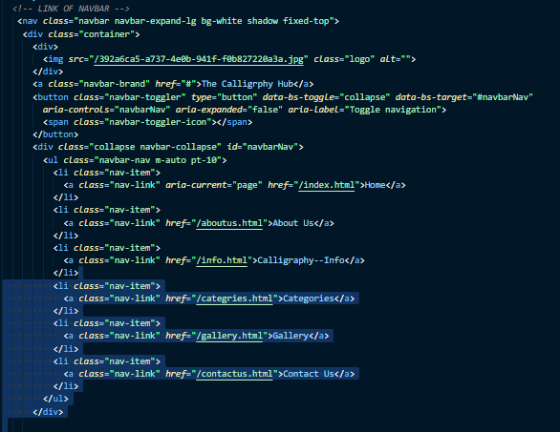

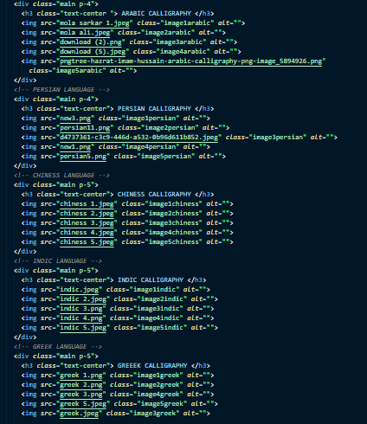

SECTION OF ABOUT US

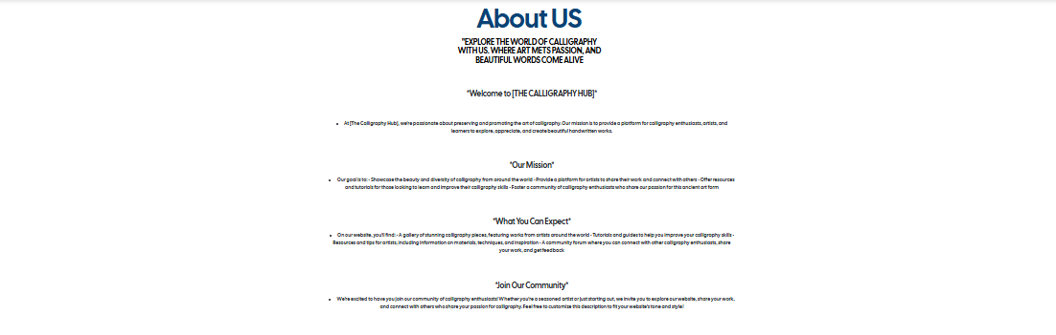

CODE OF ABOUT US

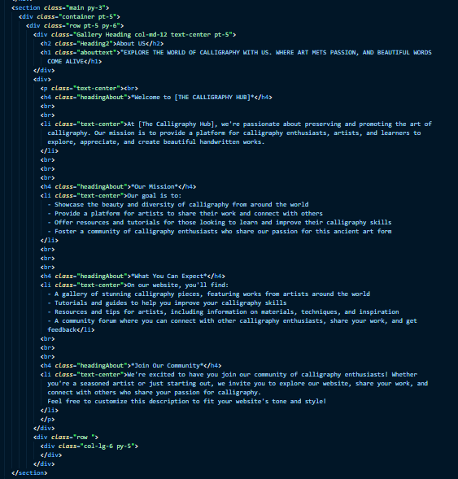

CATEGARIES PAGE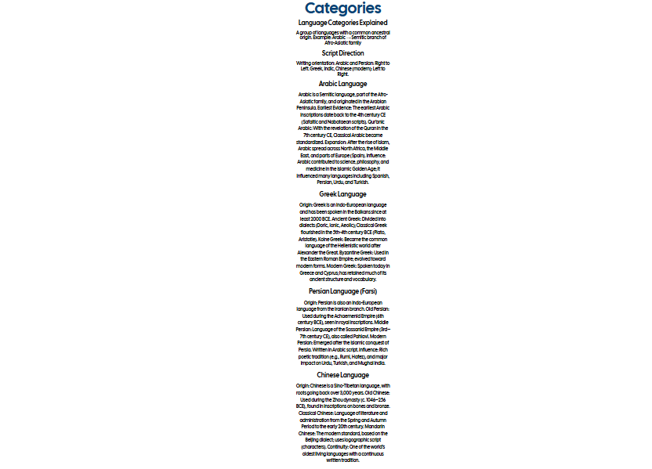

CODE OF CATEGARIES

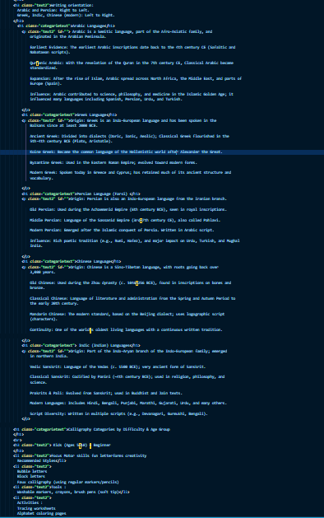

GALLERY PAGE 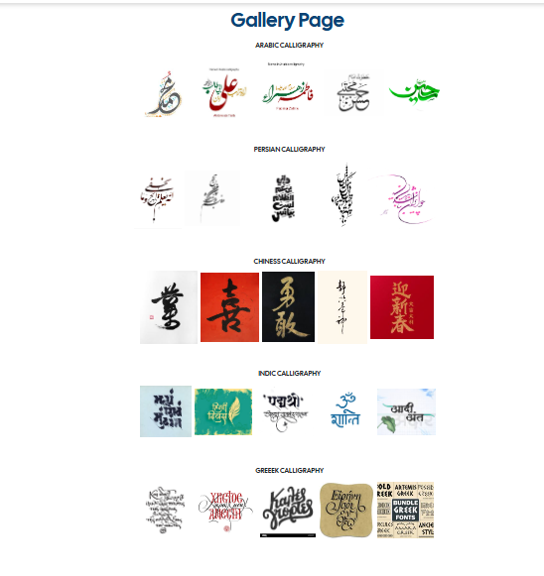

CODE OF GALLERY

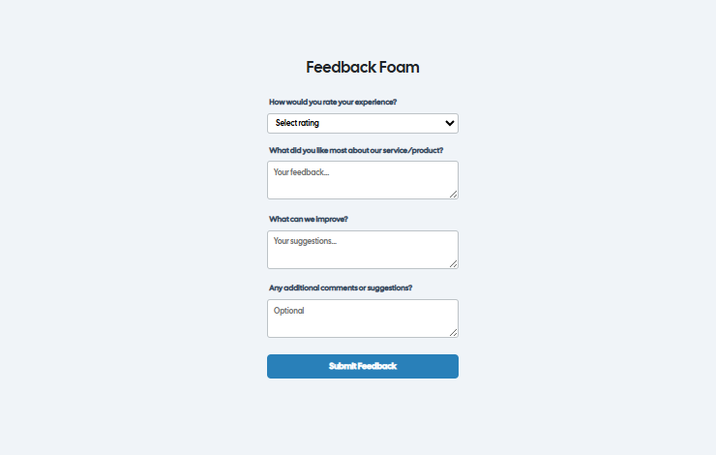 FEEDBACK PAGE

FEEDBACK PAGE CODE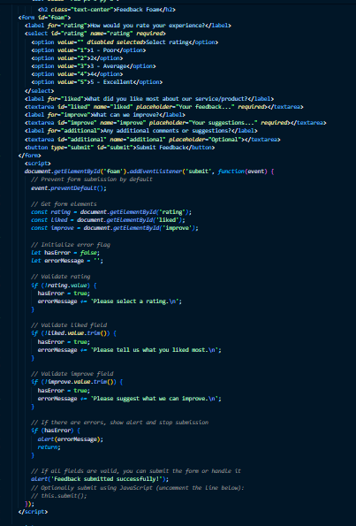

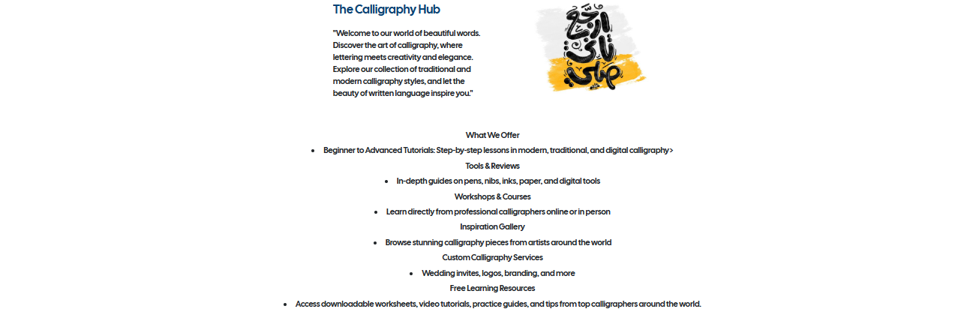 HOME PAGE

HOME PAGE CODE